Brighton Excelsior
Cycling Club

25 mile Time Trial
and
Brighton Excelsior Club Championship
Sunday 9th July 2023 starting at 7.31 am.
Course G25/93
HQ: The Steyning Centre, Fletcher's Croft, Steyning, W Sussex. BN44 3XZ
From Steyning High St: turn at mini-roundabout, down Church St (timbered houses); in 200yds turn Right at thinking man statue. HQ open from 6.00 am

Event organiser
Bob Harber, 51 Church Lane, Upper Beeding, Steyning, W Sussex. BN44 3HP
Tel: 01903 879598 and 07979 836259
Email harberbike@gmail.com

Timekeepers
Su Balcombe, Brighton Excelsior, assisted by Wendy Harman, Brighton Excelsior

(TQ) | COURSE DIRECTIONS – G25/93 | MILES
172131 | START on B2135 just south of entrance to Wappingthorn Manor | 0.00
 | Proceed on the B2135 through Partridge Green to junction with A24 | 6.71
 | Turn LEFT at A24, on to Washington RBT (take 1st exit) | 12.52
 | Turn LEFT on A283 via Bramber RBT (3rd exit) and Beeding Court RBT (2nd exit) to Adur Flyover RBT (4th exit) to TURN | 20.99
181118 | RETURN on A283 via Beeding Court RBT (1st exit) and Bramber RBT (3rd exit) to FINISH 25 yards before Canons Way | 25.00
COURSE MAP
Courtesy of SCA

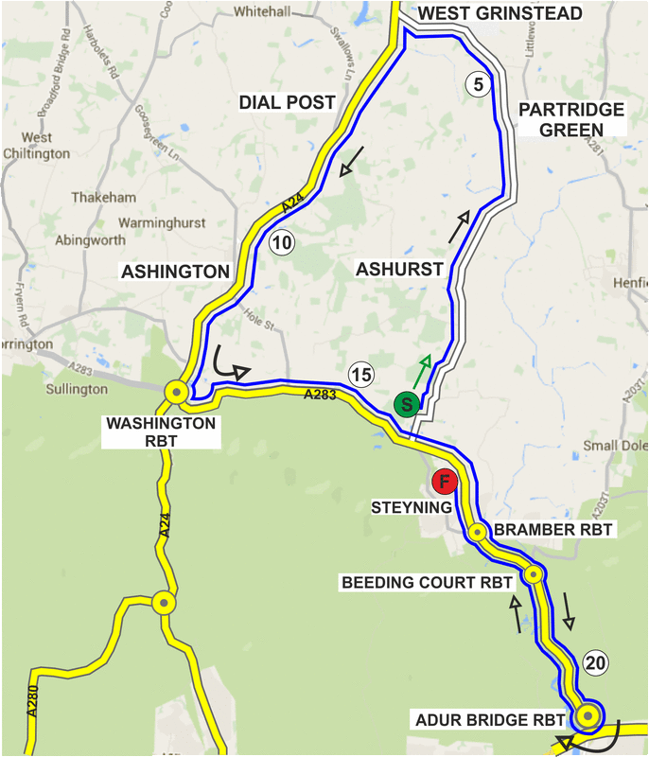
Notes to competitors
- HQ, please read the course risk notice adjacent to the signing-on sheet, for up-to-date information about the course.
- Numbers will be at the signing-on sheet in the HQ.
- EVERY COMPETITOR MUST RETURN TO HQ TO SIGN OUT, and RETURN NUMBER, in return for free refreshments kindly provided by OATOPIA.
- No cycling shoes in the HQ.
- CTT regulations require the use of a helmet that meets internationally accepted safety standards for all competitors
- CTT Regulations require that no competitor shall be permitted to start unless they have affixed to the rear of their machine a working rear red light, and to the front of their machine a working front white light, either flashing or constant, that are illuminated and positioned to be clearly visible to other road users
- Please be respectful to the neighbours in the vicinity of the HQ.
- Use the HQ toilets.
- We suggest that you allow approximately 15 minutes to ride to the start from the HQ.
- DIRECTIONS FROM HQ TO START: LEFT from HQ, RIGHT at mini-roundabout, continue through village to A283, where LEFT and immediately RIGHT for 1/4 mile to Start.
- Please do not block the entrance to Wappingthorn Manor at the Start which is regularly used.
- No times will be given at the finish.
- DIRECTIONS TO HQ AFTER EVENT: continue to ride, and turn 1st left into Steyning, up High Street. Turn left at mini-roundabout and return to the Hall.
- No U-turns are to be made within sight of the timekeepers.

Thanks to all our helpers: Chris Hodge, Domino, Steve Foster, Hanko van Beinum, Ben Miller.

OATOPIA delicious flapjacks provided by Tam Coleman.

Awards for 2023 BECC open '25'
 |  | 25 miles
Fastest Rider | 1st  2nd | £20.00  £15.00
Fastest Rider Road Bike | 1st | £20.00
Veterans on Standard | 1st | £20.00
Team (3 Riders) | 1st | £10.00 each
Brighton Excelsior Club Championship | 1st | The Foremen's Cup

Promoted for and on behalf of Cycling Time Trials under their Rules & Regulations

Brighton Excelsior CC '25' and Club Championship 09 July 2023:

Start Sheet

 |  |  |  | Road Bikes
Race Number | Start time
31 | 7.31 | Martin | Naylor | Brighton Excelsior CC | M | Vet
32 | 7.32 | Chris | Gallagher | Brighton Mitre CC | M | Senior
33 | 7.33 | Rory | Knapp | Brighton Mitre CC | M | Senior
34 | 7.34 | Sam | Cheesman | Team TMC | M | Senior
 |  |  |  | Time Trial Bikes
35 | 7.35 | Jez | Shotter | Brighton Excelsior CC | M | Vet
36 | 7.36 | Vic | Haines | Old Portlians CC | M | Vet
37 | 7.37 | Mike | Marchant | Southdown Velo | M | Vet
38 | 7.38 | David | Smith | VC de Londres | M | Vet
39 | 7.39 | Matt | Woodhart | Team TMC | M | Vet
40 | 7.40 | Roland | Kitson | Horsham Cycling | M | Vet
41 | 7.41 | John | Marinko | Brighton Mitre CC | M | Vet
42 | 7.42 | Paul | Tippett | Crawley Wheelers | M | Vet
43 | 7.43 | Ian | Cheesman | Worthing Excelsior CC | M | Vet
44 | 7.44 | Ed | Jarman | Brighton Excelsior CC | M | Vet
45 | 7.45 | Donald | Parker | Brighton Mitre CC | M | Vet
46 | 7.46 | Simon | McNamara | Sigma Sports | Cannondale RT | M | Vet

Promoted for and on behalf of Cycling Time Trials under their Rules & Regulations

